Order Of Service

Singing: Psalm 31—CW page 77

Reading: Psalm 22

Opening Hymn: TLH 62

Reading: Revelation 6:1-8

Request Hymn: CW Supplement 752

Reading: John 6:1-15

Sermon Hymn: TLH 17

Sermon Text: Song Of Solomon 5:1

I Am Come!

Prayer

The Apostles’ Creed, TLH page 12

Holy Communion

The Lord's Prayer

The Blessing

Closing Hymn: TLH 78

* * * * * * * * * * *

Koinonia Hour

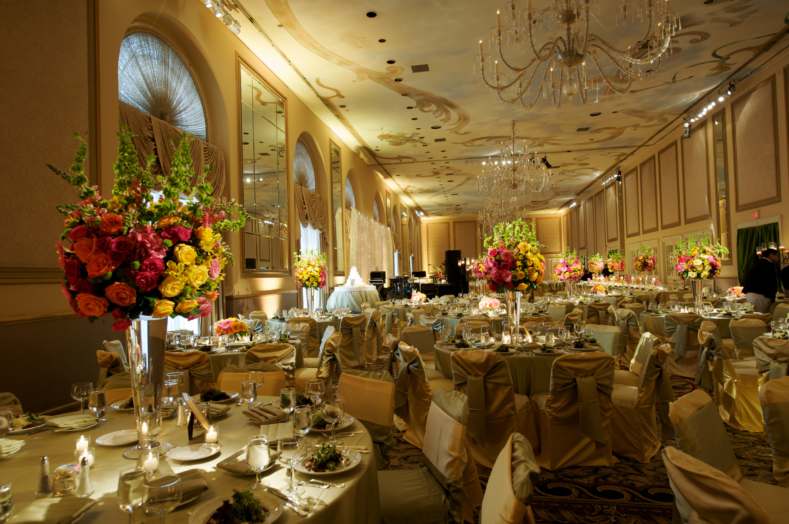

The Heavenly Banquet

Water
Of
Life

6 November 2016

W A T E R O F L I F E

Independent Christian Church—Conservative Lutheran Doctrine

Worship Service: 9:30 a.m. Bible Study: 10:45 a.m.

Larry Cooper, Pastor E-Mail address:
111 N. Ridge Road lcooper@wateroflife.cc
Coon Valley, WI 54623 Web Site:
Phone: (608) 452-2105 www.wateroflife.cc

* * * * * * * * * * * * * * * * * * * * * * * * * * *

Sermon Text: Song Of Solomon 5:1

I Am Come!

* * * * * * * * * * * * * * * * * * * * * * * * * * *

Song of Solomon 5:1 I am come into my garden, my sister, my spouse: I have gathered my myrrh with my spice; I have eaten my honeycomb with my honey; I have drunk my wine with my milk: eat, O friends; drink, yea, drink abundantly, O beloved.

* * * * * * * * * *

The first miracle Jesus performed during his years on this earth was when he turned water into wine. Fittingly, this miracle took place at a marriage in Cana of Galilee. John 2:1-11.

Notice the connection here in Song Of Solomon between 4:15 and 5:1.

In 4:15 water is present in abundance. The Bride is described as being “a fountain of gardens, a well of living waters, and streams from Lebanon.” Now here in 5:1 the Bridegroom has come into his garden. And he says—“I have drunk my wine with my milk.” And he invites his Bride to “Drink! Yea, drink abundantly!”

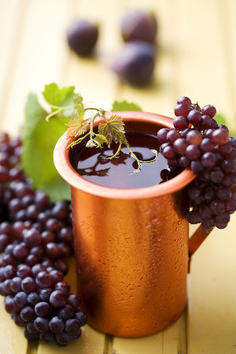

The theme has changed from water to wine! And the truth, as the poet writes: “ Grow old along with me! The best is yet to be!”

